Judea Dumont

CS230 Data Structures

Individual Project 1

Contents

Test Plan: 2

# Test Plan:

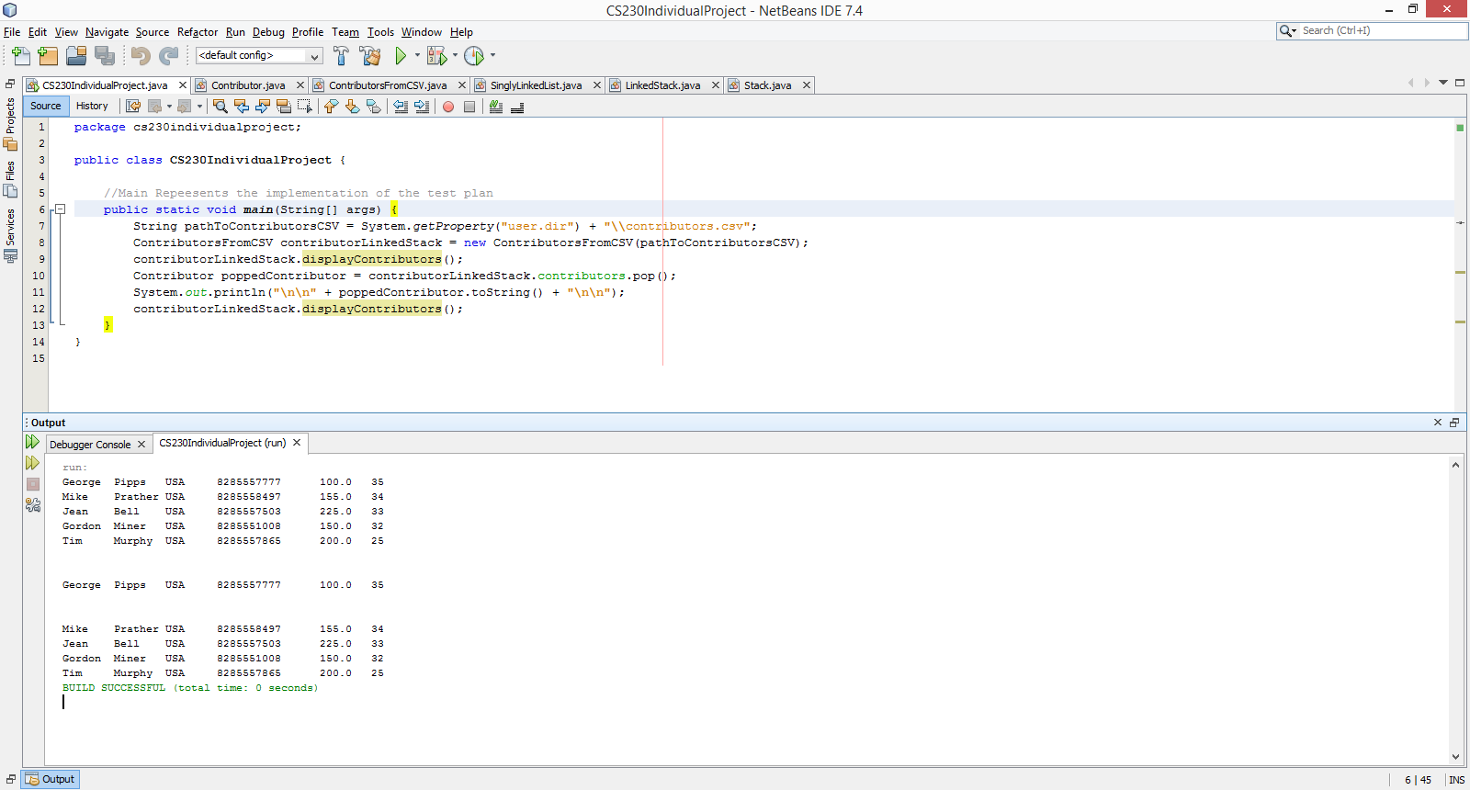

1. The programs main function contains the path to obtain the csv file. If the file is not renamed and remains in its original directory, it will do this on its own with the get property of the user.dir function.
2. It parses the CSV upon instantiating an object of type Contributors from CSV, which loads the plain text information into organized java objects.
3. The data structure it loads the java objects into is a manually implemented LinkedStack.
4. The linked stack has its pop function called and that contributor is displayed.
5. The list is shown again to show that the first entry into the linked stack has been popped off.